Superhero Kids Fund
2021 First Quarter Report
(January - March 2021)

Dell Children’s Speciality Pavilion

As you well know, Dell Children’s is in growth mode and will continue this trajectory for the foreseeable future. The Children’s Blood & Cancer Center is poised to move into the first of the new buildings in May of 2021. This new pavilion will host the pediatric neurology, orthopedics, and hematology/oncology outpatient services … and will be attached to the hospital.
Staff are preparing for the move by clearing out, cleaning up, and packing our bags. While we are all keenly aware that we have needed more space for quite some time, it’s hard to leave our home of the last fourteen years. Truly, it will be a bittersweet moment when we leave the Strictly Pediatrics building.
We can’t wait to show you around our new space … which at the moment is looking absolutely cavernous to us!
We also want to note that we realize we may be a bit sparse on stories and pictures this quarter simply because we’re taking as much extra time as we can to support our patients and their families as we work to get ready to move AND especially as all of us continue to process and cope with the ongoing challenges of the 2020/2021 COVID-19 pandemic … while working to remain cautiously optimistic.

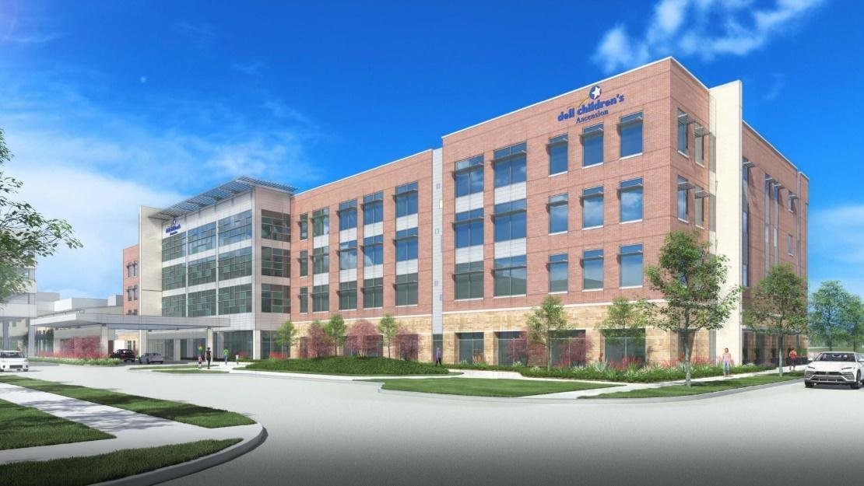

march is child life month

March is Child Life Month, a month when hospitals celebrate Child Life Specialists
and the Child Life profession through education and awareness of their work.
Child Life Specialists help normalize the hospital experience and work to
bring joy and comfort to hospitalized kids and their families.

Thanks to SuperHero Kids, during national Child Life Month, our inpatient and outpatient Child Life Specialists were able to celebrate their profession with both colleagues and patients. The Child Life team used SHK funds to buy the necessary supplies to decorate the clinic with St. Patrick’s Day and Easter themes in order to create an uplifting and festive environment for our patients and their families. They further engaged patients and their families by dressing up as characters from Disney and children’s literature, along with creating game days to entertain everyone from our most senior doctors to the youngest of our kids.

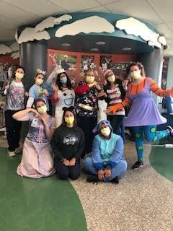
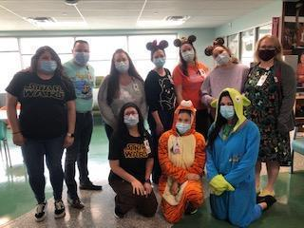

Financial Assistance

It’s no news at this point that the COVID-19 Pandemic of 2020/21 has been a tough time financially for people. Thankfully, the SuperHero Kids Fund has been able to help patient families with mortgage payments and utility bills.

Katie Tripp, Social Worker for the CBCC notes two families in particular who stand out in our minds as incredibly deserving of your generosity:

Katie used the SuperHero Kids Emergency Fund to pay off one grandmother’s large utility bill. This grandmother was unexpectedly placed in the position some time back of becoming the sole caretaker of four grandchildren, one of them a CBCC patient who has been hospitalized twice in the last two months. This major life change has since severely limited the grandmother’s ability to work; and she found herself seriously behind in paying household bills. You provided her the resources – and the grace – to catch up on her utility bills.
Another patient family also led by a grandmother has been caring for a CBCC patient and two younger twin siblings. She also has had to limit her working time and has suffered a distinct loss of income. Your generosity allows us to provide a full mortgage payment for her and the children. All in all, having the backing of SuperHero Kids allows our social work team to work with families on the daily and equip them with the resources to battle financial challenges that arise.

Superhero Kids Fund Support
2021 First Quarter Accounting Report

During the first quarter (January through March 2021), the Superhero Kids Fund
provided $ 14968.56 in direct financial assistance and $149.00 in program assistance.

DATE | DIRECT FINANCIAL ASSISTANCE EXPENSE ITEM | COST | TOTAL
1.5.21 | electric bill | $ 352.39
1.5.21 | utility bill | $ 500.00
1.5.21 | phone bill | $ 400.00
1.6.21 | move-in expenses | $ 500.00
1.8.21 | mortgage assistance | $ 1,000.00
1.11.21 | utility bill | $ 300.00
1.14.20 | electric bill | $ 317.77
1.15.21 | utility bill | $ 97.06
1.27.21 | move-in expenses | $ 255.00
1.29.21 | car insurance | $ 320.34
2.1.21 | wifi bill | $ 52.07
2.1.21 | mortgage assistance | $ 1,455.00
2.12.21 | electric bill | $ 267.37
2.12.21 | utility bill | $ 149.18
2.12.21 | car insurance | $ 337.78
2.12.21 | car insurance | $ 292.52
2.12.21 | phone bill | $ 184.09
2.22.21 | phone bill | $ 115.81
2.23.21 | phone bill | $ 917.88
2.25.21 | electricity bill | $ 145.43
3.1.21 | car insurance | $ 186.09
3.1.21 | utility bill | $ 255.89
3.2.21 | Funeral | $ 2,000.00
3.5.21 | gas bill | $ 201.49
3.8.21 | gas bill | $ 134.48
3.8.21 | electric bill | $ 125.81
3.11.21 | electric bill | $ 390.78
3.15.21 | phone bill | $ 200.00
3.15.21 | electric bill | $ 328.98
3.15.21 | car insurance | $ 299.38
3.15.21 | utility bill | $ 142.39
3.10.21 | rent assistance | $ 1,775.00
3.18.21 | utility assistance | $ 230.00
3.18.21 | electricity bill | $ 187.07
3.29.21 | utility bill | $ 551.51
 | DIRECT FINANCIAL ASSISTANCE  Quarterly Total |  | $ 14,968.56
PROGRAM ASSISTANCE
EXPENSE ITEM(S)
March 2021 | Child Life decorations for clinic | $149.00
 | TOTAL PROGRAM ASSISTANCE |  | $ 149.00
 | TOTAL 2021 FIRST QUARTER EXPENSES |  | $ 15,117.56

SUMMARY TO DATE
Superhero Kids Fund Support  (December 2011 – December 2020) |  | $1,184,890.60
Superhero Kids 2021 First Quarter Summary
Direct Financial Assistance | $ 14968.56
Program Assistance | $ 149.00
TOTAL 2021 1ST QUARTER EXPENSES |  | $ 15,117.56
TOTAL SUPERHERO KIDS FUND SUPPORT  (December 2011 – March 2021) |  | $ 1,200,008.16

